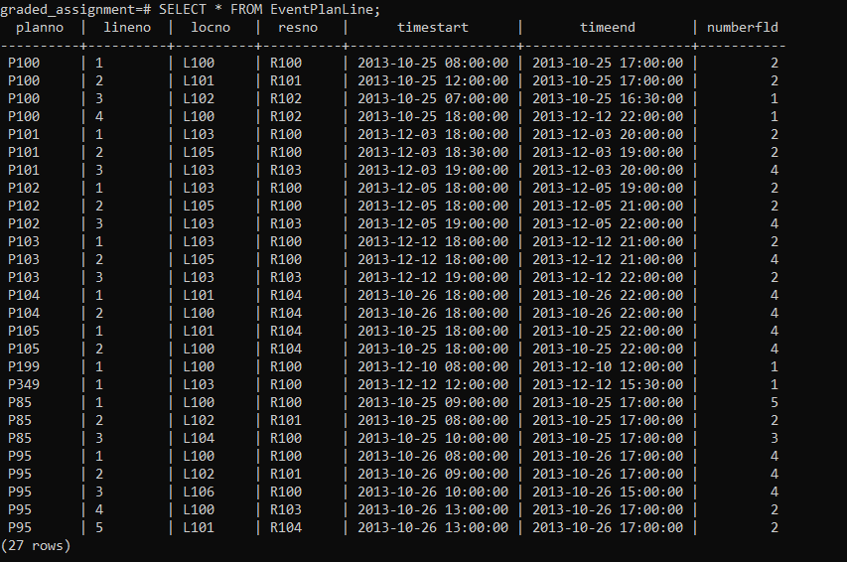 CREATE TABLE EventPlanLine (

planNo CHAR(8) NOT NULL,

lineNo CHAR(8) NOT NULL,

locNo CHAR(8) NOT NULL,

resNo CHAR(8) NOT NULL,

timeStart TIMESTAMP NOT NULL,

timeEnd TIMESTAMP NOT NULL,

numberFLD INTEGER NOT NULL,

CONSTRAINT PK_EventPlanLine PRIMARY KEY (planNo, lineNo),

CONSTRAINT FK_EventPlan FOREIGN KEY (planNo) REFERENCES EventPlan (planNo),

CONSTRAINT FK_Location FOREIGN KEY (locNo) REFERENCES Location (locNo),

CONSTRAINT FK_ResourceTbl FOREIGN KEY (resNo) REFERENCES ResourceTbl (resNo)

);